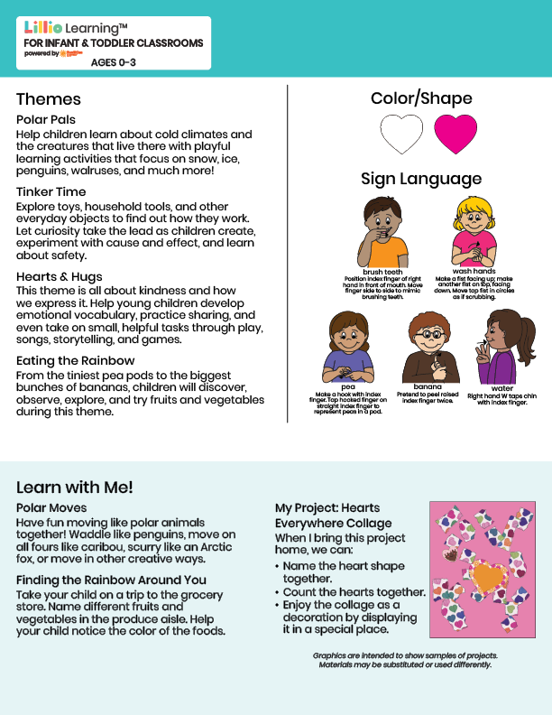
Add Name or Logo Here
Jan/Feb 2026
NEWSLETTER



Add Notes Here

